Hustopeče region in 3D
Elementary school Hustopeče, Nádražní 4, district Břeclav, contribution organization
Nádražní 4, 693 01 Hustopeče
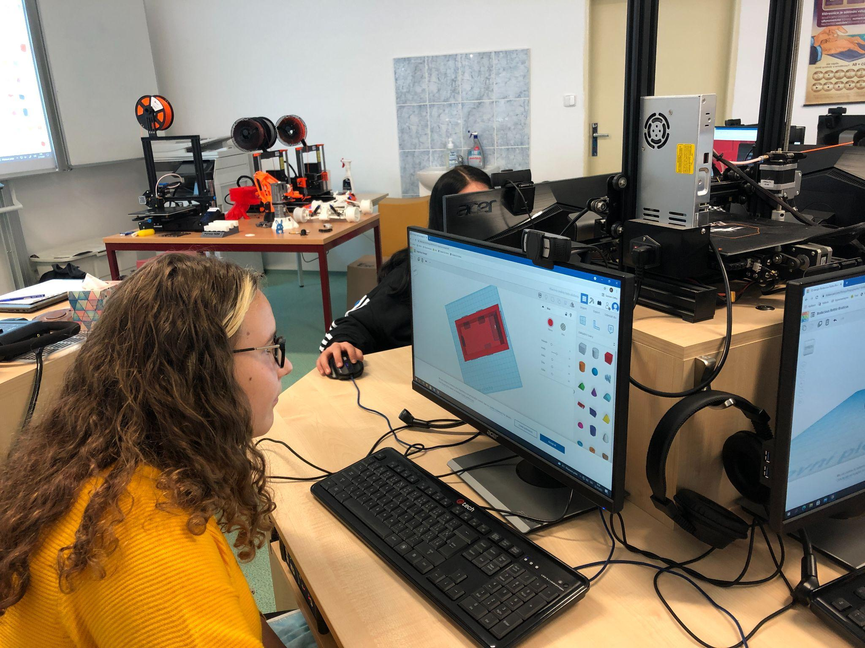
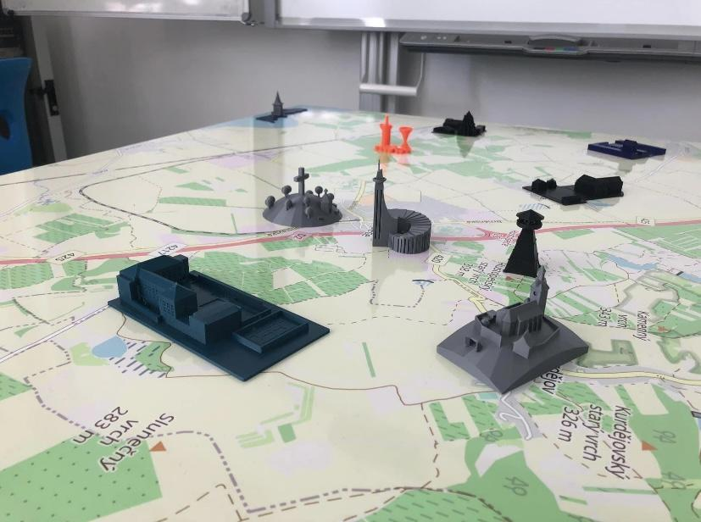
Content

Basic information about the project 3
Project description 3
Project objectives 3
What age group is the project intended for? 4
What skills will students learn? 4
Time-consuming implementation 5
The role of the teacher and the role of the student 5
Materiální vybavení potřebné k realizaci projektu 6
Financial complexity of the project 8
Project preparation 8
Creation of 3D models 11
Software - applications used in the preparation of models 14
Tinkercad 14
PrusaSlicer 20
Creating a base map 24
Online map and its creation 25
Final outputs of the project 30
Summary - benefits and pitfalls 31

Basic information about the project

Project description

Hustopečsko in 3D is a project of 8th grade students implemented in the 2021/2022 school year, the main output of which is a physical map of the Hustopečsko region with 3D objects of places.

The 3D objects represent the places that the pupils themselves designed and selected. These are places to which they have a personal relationship or places where they like to go. E.g. lookout tower, pond, stadium etc. As part of the project, both a physical map and an online map referring to the given places were created. There is also a short vignette with a description for each object or place.

All outputs are available on the project website, where the student team also kept a project diary.

Project objectives

- Get to know 3D printing technology and its principles.
- Understand the application of 3D printing in practice and know its advantages.
- Learn to perceive the proportions of various objects around us.
- Learn to work with programs for creating 3D objects, familiarize yourself with the basic control elements of the program and model your own designed objects.
- Work with 3D models.
- Develop informational thinking.
- Develop technical thinking.
- Get better at working with an online map.
- Learn how to create a simple website.
- Work in a team, develop social, communication, digital and work competences.
- Get to know our region better through lesser-known places.
- Purchase new equipment and material for 3D printing for the school.

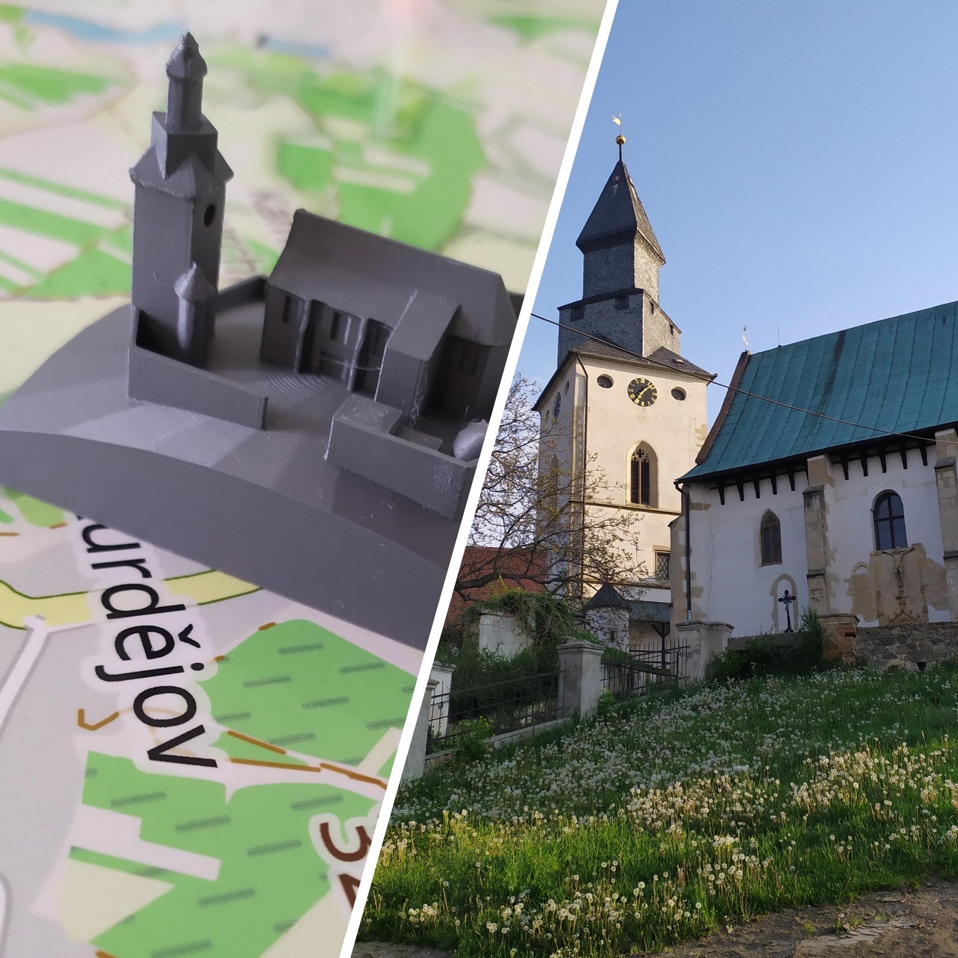
What age group is the project intended for?

In our case, we worked on the project with a group of 8th grade students, i.e. with children aged 13. Of course, it can be implemented with any age group of students from 5th to 9th grade.
No previous knowledge of programs for creating 3D objects or previous experience with 3D printing as such is necessary. The participants of the project learn everything in its implementation.
The activities implemented lead to the motivation of different ages, because it is a topic that is interesting, attractive and personal for children. In addition to working with modern technologies, the project offers them to create a material output - a map with objects that directly touch their personal lives.

What skills will students learn?

- At the end of the project, students will be able to:
- Basics of 3D printing
- Working with Tinkercad
- Working with the Slicer program
- Creating an online map using freely available applications
- Work in a team
- Implementation of a complex project

Time-consuming implementation
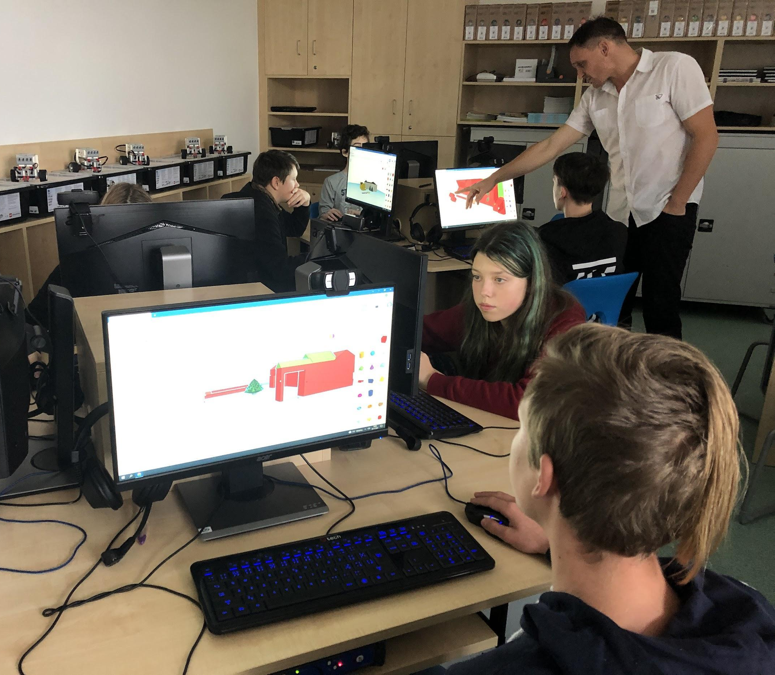
Of course, the total time required for the implementation of the project may depend on how many hours per week the participants devote to the project and how many pupils are involved in the project.
We have divided the project Hustopečsko in 3D into several phases. We devoted sufficient space to each of them, mainly because the students worked on the project independently. Our function was more to mentor and supervise. We worked on the project for five months with approx. 1 teaching hour per week (meeting of the project team) + 1 hour per week of independent student work. Our team consisted of eight pupils who were the main actors. During some phases of the project, the team was expanded by other so-called collaborators who designed models for the map as part of the computer technology subject.
The most time-consuming part was the final part - the actual printing of the models, which itself takes quite a long time. During it, we discovered errors and shortcomings in the designs, and it was therefore necessary to rework the models and print them again.

The role of the teacher and the role of the student

Role of the teacher: mentor, advisor, support, technical and organizational provision of the project, purchase of aids, consultation, communication with a third party (school management, project publicity, advertising agency, etc.).
Role of the student: project organization and implementation, website creation, record keeping, online map creation, diary keeping, photo documentation, modelling, selection of locations for the map, distribution and presentation of the project

Materiální vybavení potřebné k realizaci projektu

Device:
3D Printer
3D tiskárna Original Prusa i3 MK3S+ | 3D tiskárny Original Prusa přímo od Josefa Průši (prusa3d.com)
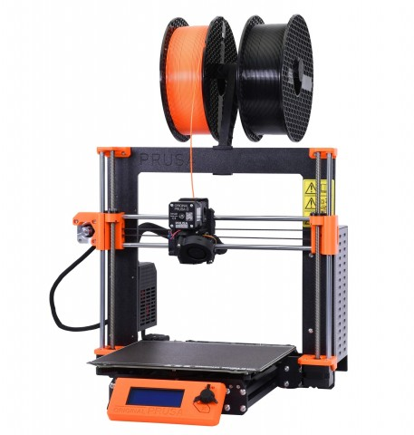

filament for printing models
PLA
PLA | 3D tiskárny Original Prusa přímo od Josefa Průši (prusa3d.com)

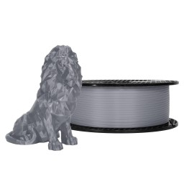

PETG
PETG | 3D tiskárny Original Prusa přímo od Josefa Průši (prusa3d.com)
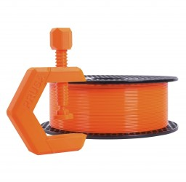

set of modelling knives
SET NOŽE 50 Sada modelářských nožů Velleman (agama-model.cz)
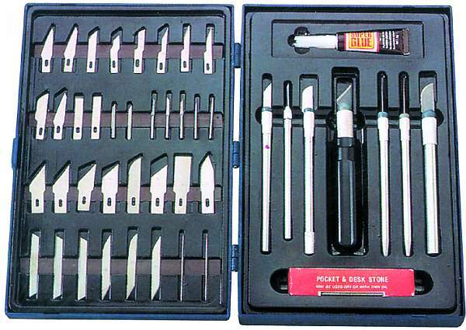

modelling glue
Glue with needle - Contacta Profi Mini 12.5g, Revell 39608 | Modelar - plastic models (modelar-eshop.cz)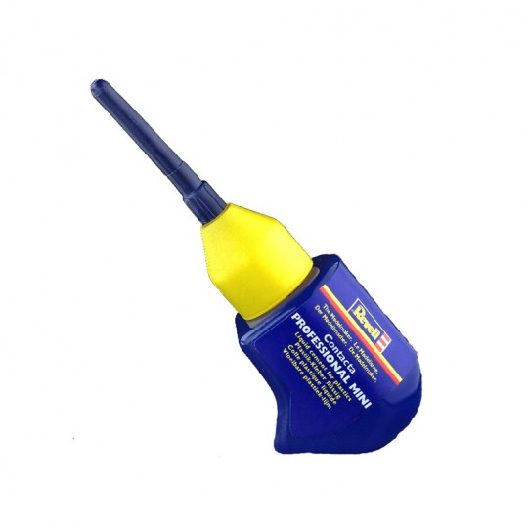

Financial complexity of the project

Basic components and material
3d Printer | 28 490 Kč
PLA filament | 699 Kč
PETG filament (various colours) | 699 Kč
SD card (128 GB) | 429 Kč
map base (image foam 1,300 x 900 mm, 3mm); including graphic processing | 3 000 Kč
In total | 33 317 Kč

Other components and material
set of modelling knives | 690 Kč
modelling glue | 105 Kč

Project preparation

This stage of the project can include all the activities that preceded the work with programs for creating models and their printing itself.
First, it was necessary to prepare the space where the 3D printers will be located. The enemy of 3D printers is dust. It is therefore advisable to prepare a space where the printers can be closed or well covered. Of course, special boxes for 3D printers are already available on the market. You can also make boxes according to various instructions (https://josefprusa.cz/jak-si-snadno-a-levne-vyrobit-box-na-3d-tiskarnu/).
The noise of the printing itself is also not negligible. It is therefore advisable to have printers outside the classroom, or to start printing at a time when there are no classes.
Since we also purchased one printer in the form of a kit, it had to be assembled. However, for beginners, we recommend getting one printer assembled, and if possible, another in the form of a kit, which is cheaper and thanks to which students have the opportunity to better understand the overall functionality of the device. With the printer - kit, we had more work to do when calibrating the axes.

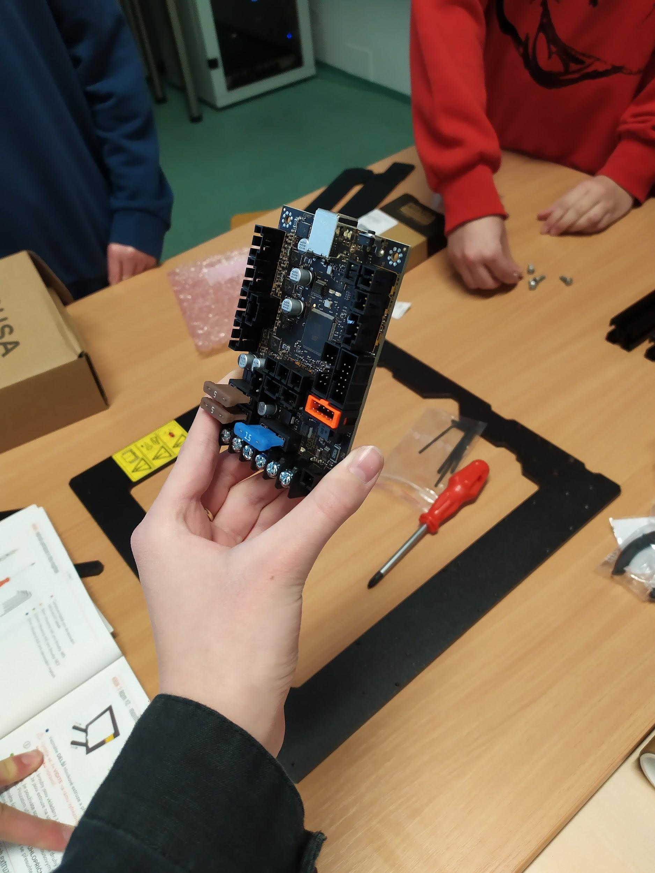
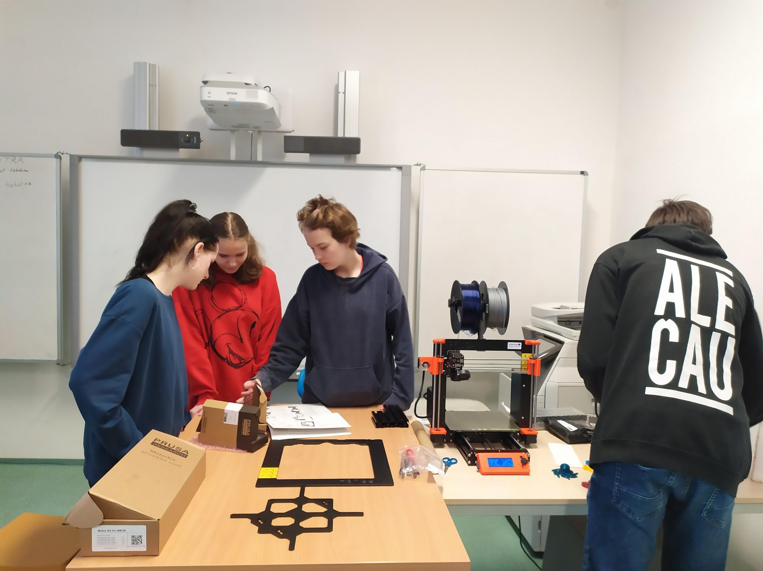
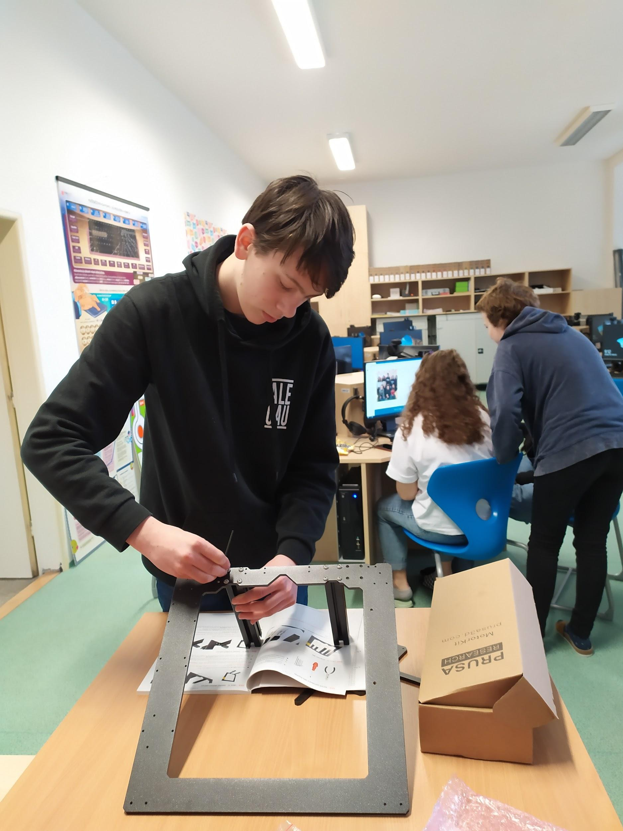

At one of the first meetings, we created a folder on the school drive (Google Workspace), which we used to share all project materials, for planning, recordings, outputs, maintaining a photo gallery, etc. It made our work much easier both during implementation and in the final phase in the creation of final outputs intended for presentation. Of course, all team members had access to the folder, pupils as contributors, teachers as editors.
Right from the beginning, we wanted to involve as many pupils as possible in the project. One of the ways of choosing the places that we will place on the map was to ask other students. Students created a questionnaire for their peers from our school, which, thanks to its location near the railway station, is visited by pupils from the whole micro-region. They asked them where they live, what places they like and how they actually discovered them. From the 140 respondents' answers, the team then selected 16 places, which we selected for the map and for which we created 3D models and vignettes. These are places that are important for individual municipalities in the region, that are more or less well-known and that have a special personal value for our students.
We created the questionnaire in the Google Workspace application, which we use at school for communication with students, teaching support etc.
A sample of his survey results - Where do you live
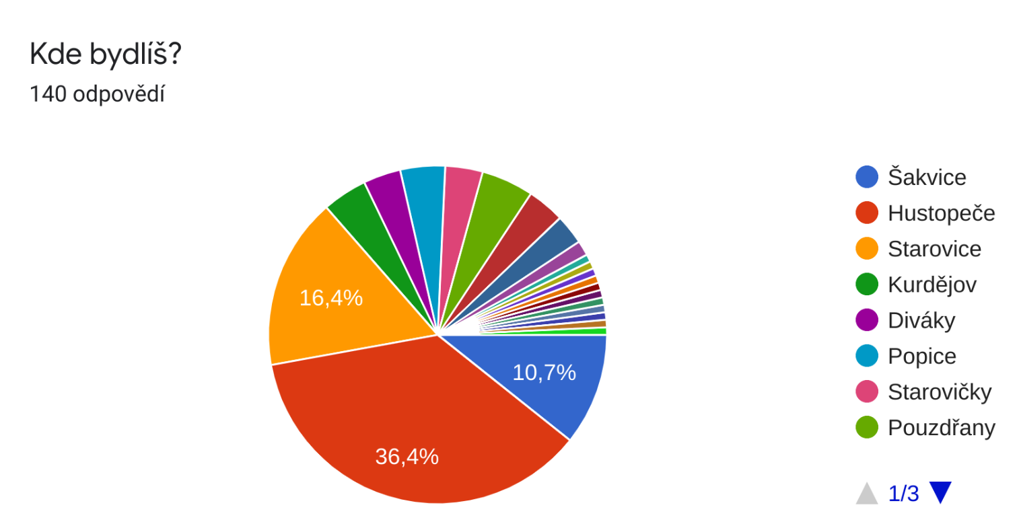

Why is it your favorite place (is there peace?, nice view, is it beautiful, because you grew up, go to school, have a grandmother there or go there a lot, go there with friends and play football, have everything we need there, Because it is nice there and their use to be water instead of the village, Because me and my friends have lot of memories from there, Because I have good memories from there and the place is nice)
The students recorded all the outputs from our work on the website, which was created at the beginning of the project for the purpose of presenting.
The appearance, management of the website, insertion of records and photos was entirely under the direction of the students. Here again, the teachers take on the role of advisors, where they come up with suggestions that the students either implement or not. We created the website in Google Workspace, which offers easy but effective web hosting. Thanks to the fact that all the students in our school have their own account, it was very easy to share the website within the team, and thus each member had editing rights and could contribute to the website.
The website address is of course available from our school website, where, among other things, we have regularly informed about the happenings in the project.
Project website: https://sites.google.com/zs-nadrazni.cz/hustopecsko3d
On the page, the visitor will find the project diary, where the students recorded important milestones, as well as an online map of the microregion with all the places that we have selected for the 3D map. Our team section, where the students introduce themselves, and last but not least, videos, photos and articles on the website from the media that wrote about the Hustopečsko in 3D project.

Creation of 3D models

When rendering objects into a 3D map, we were based on two concepts: to represent the given place as believably as possible, or to bring the object closer symbolically.
We chose our school building as the first for an accurate representation. That is, a place that everyone knows for sure. We went around the school together, took pictures, and measured. We explained what to pay attention to when modeling (e.g. individual proportions, aspect ratios). We also showed how web portals such as google maps or mapy.cz can be used to measure distances.
Students were instructed to similarly grasp the objects of their choice and transfer them realistically.
Pupils photographed and measured the school using mobile devices

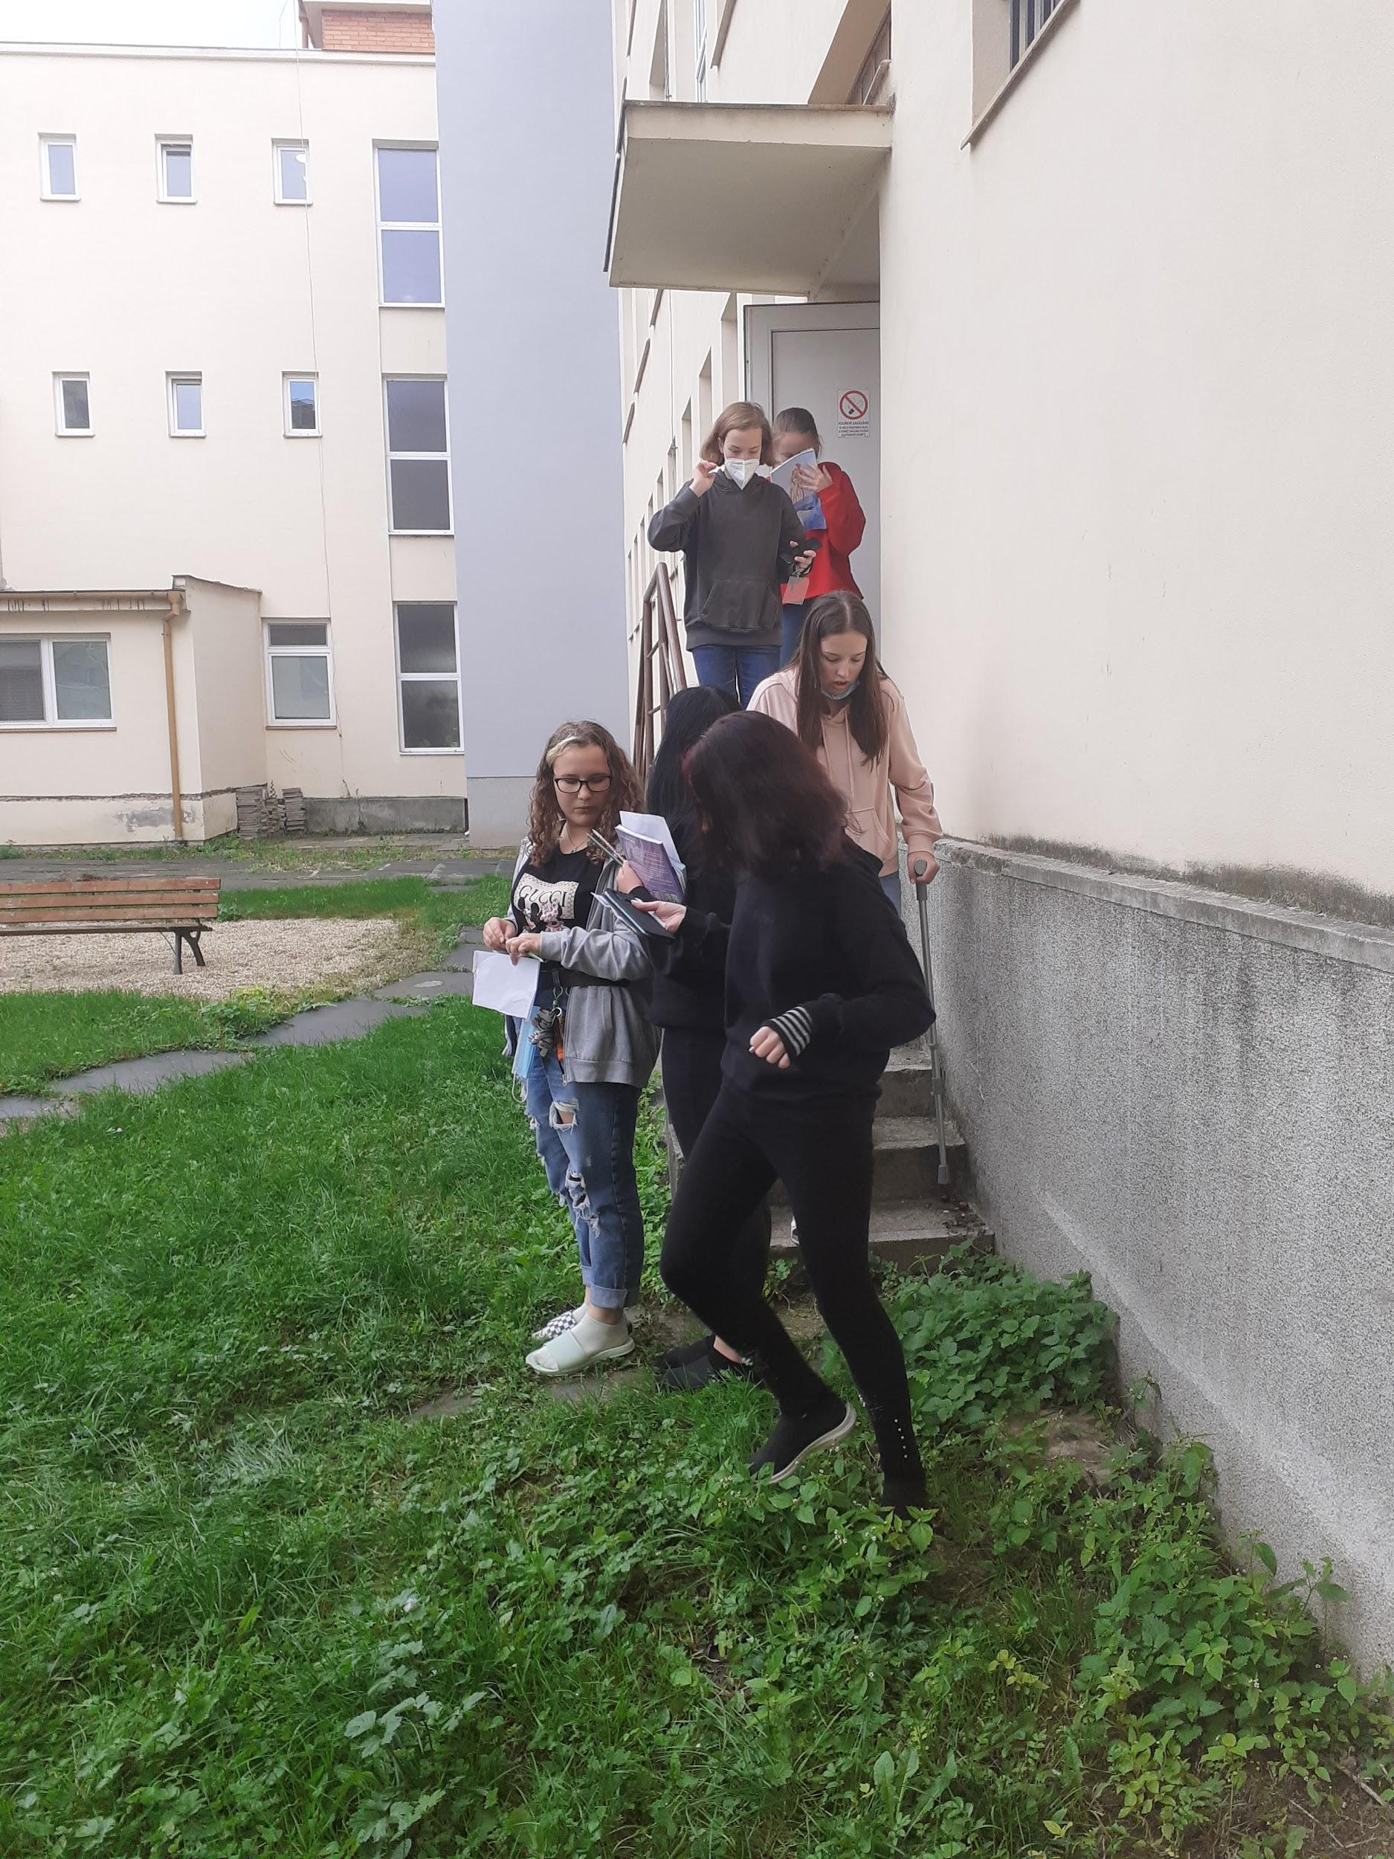
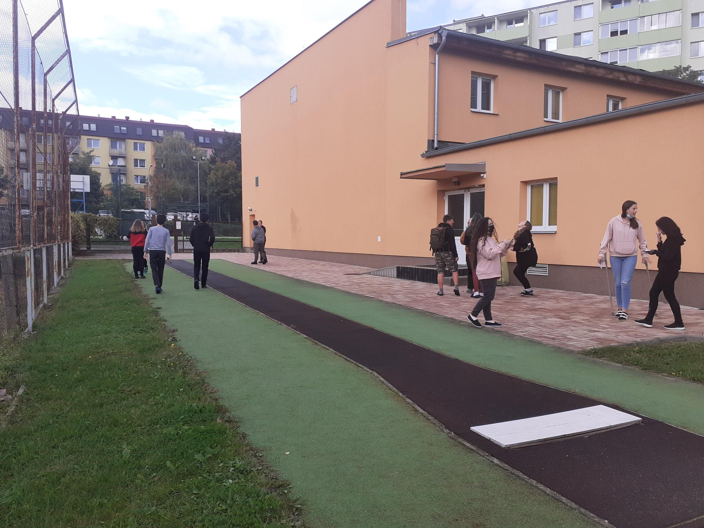

Students modelled 3D objects in the Tinkercad application
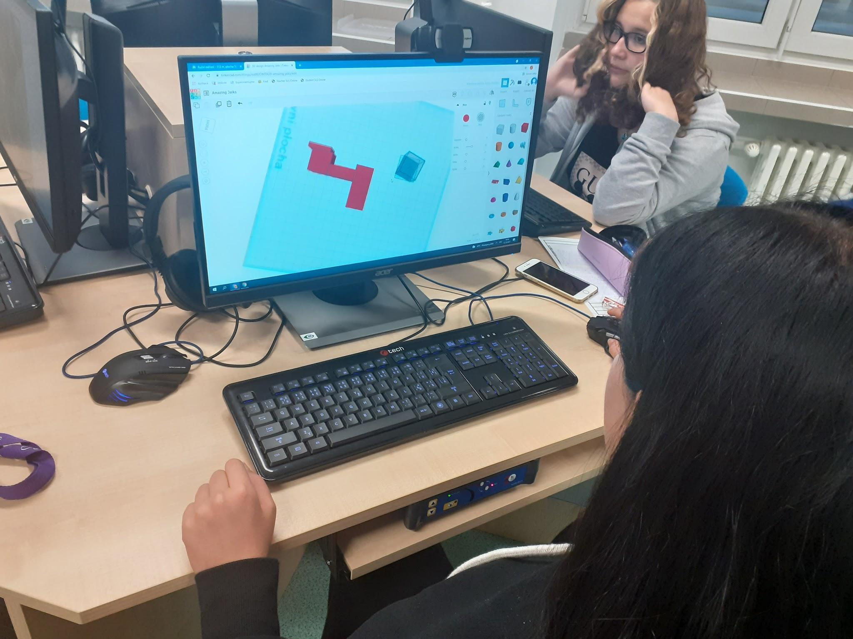

A sample of the created model of our school
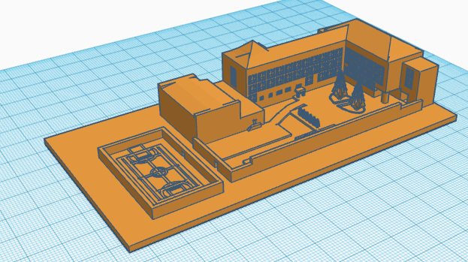

In the representation of the symbolic, it was mainly about capturing the basic characteristic, association, feeling of the place chosen by the student. The possibility of printing the object on a 3D printer also had to be remembered.

A symbolic model characterising winemaking
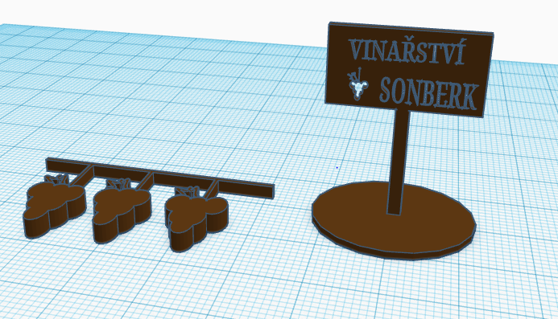

Software - applications used in the preparation of models

As complete beginners with 3D printing, we were faced with the decision in which program to model the objects. After several recommendations and, last but not least, the workshop led by the boys from SVČ Lužánky, the choice was made for the Tinkercad online application (www.tincercad.com).
Because each 3D geometry needs to be converted into information that the 3D printer can understand, we must also choose a slicer, i.e. a program that will generate the given set of instructions for the printer. Here we have chosen the PrusaSlicer recommended by the manufacturer of our printers (PrusaSlicer | Original Prusa 3D printers directly from Josef Průša (prusa3d.com)).

Tinkercad

Tinkercad is a free and simple 3D design application. It works as an online tool and can be launched from www.tinkercad.com from any browser.
This program is suitable for absolute beginners of modelling in space. Just register or sign in with a Google or Apple account and the intuitive work can begin.
The basic building blocks are three-dimensional shapes that can be easily dragged from the library on the right side of the screen onto the desktop with the mouse.

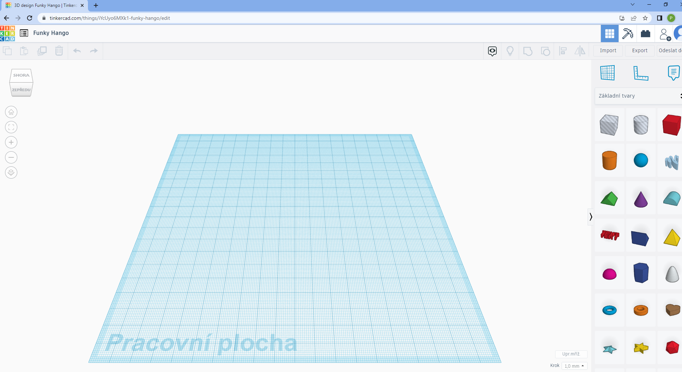

These basic objects can then be modified. The menu offers a wide range of options, for example:
- drag the active red square to resize in all three directions
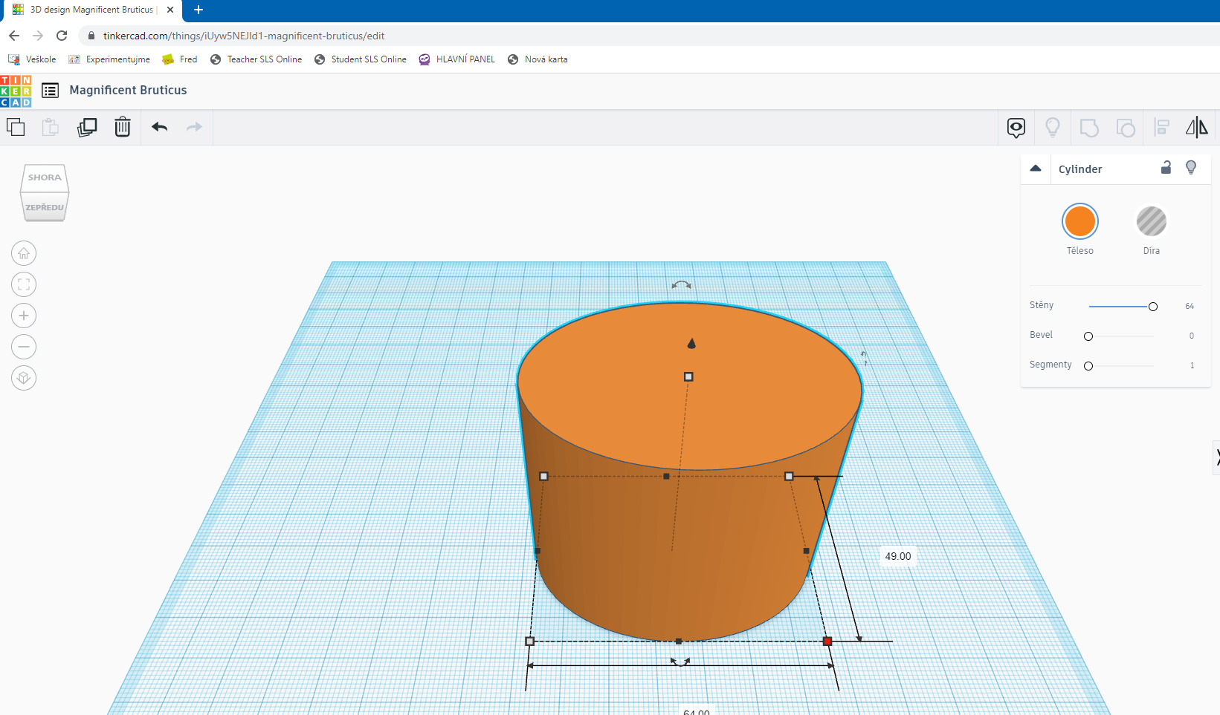

- use the arrows to rotate
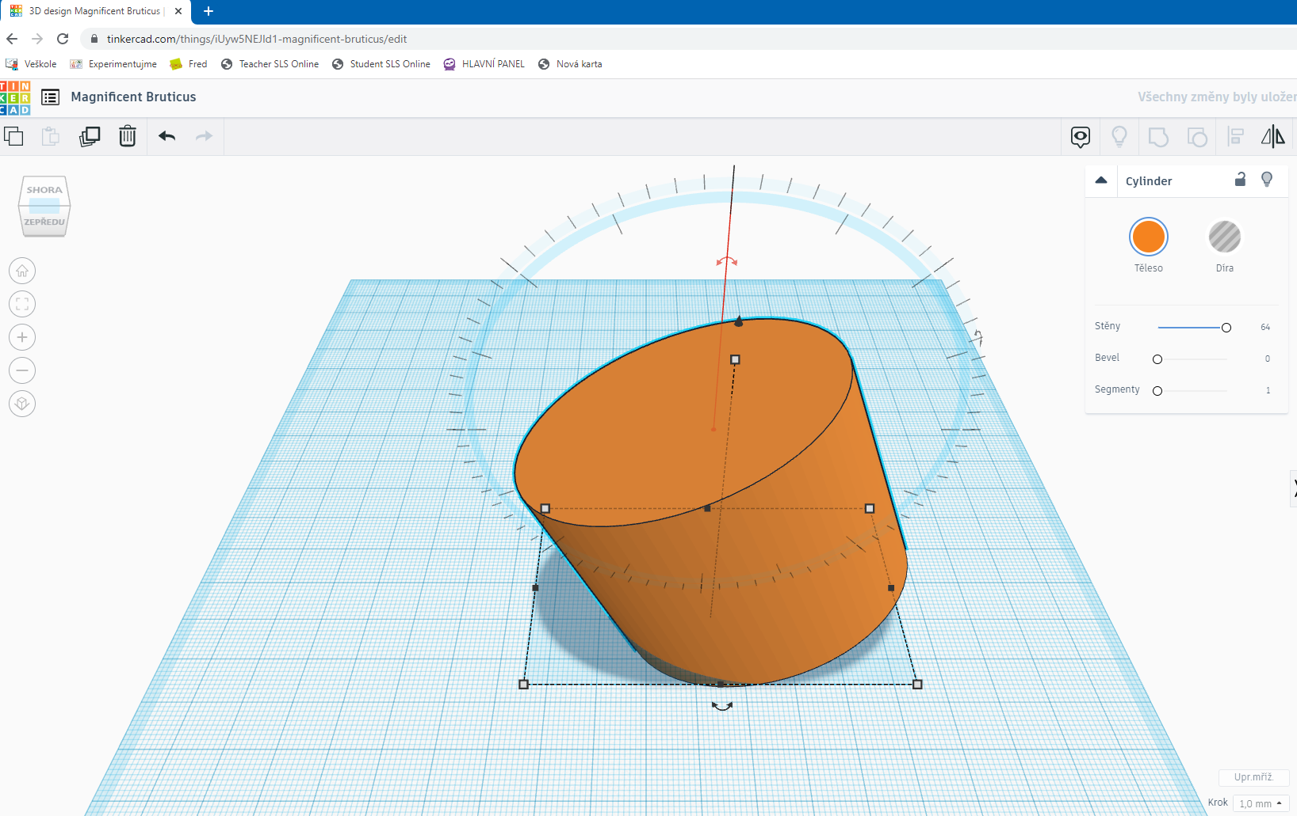
- hrough the dialog box, change the shape - number of walls, skew, segments
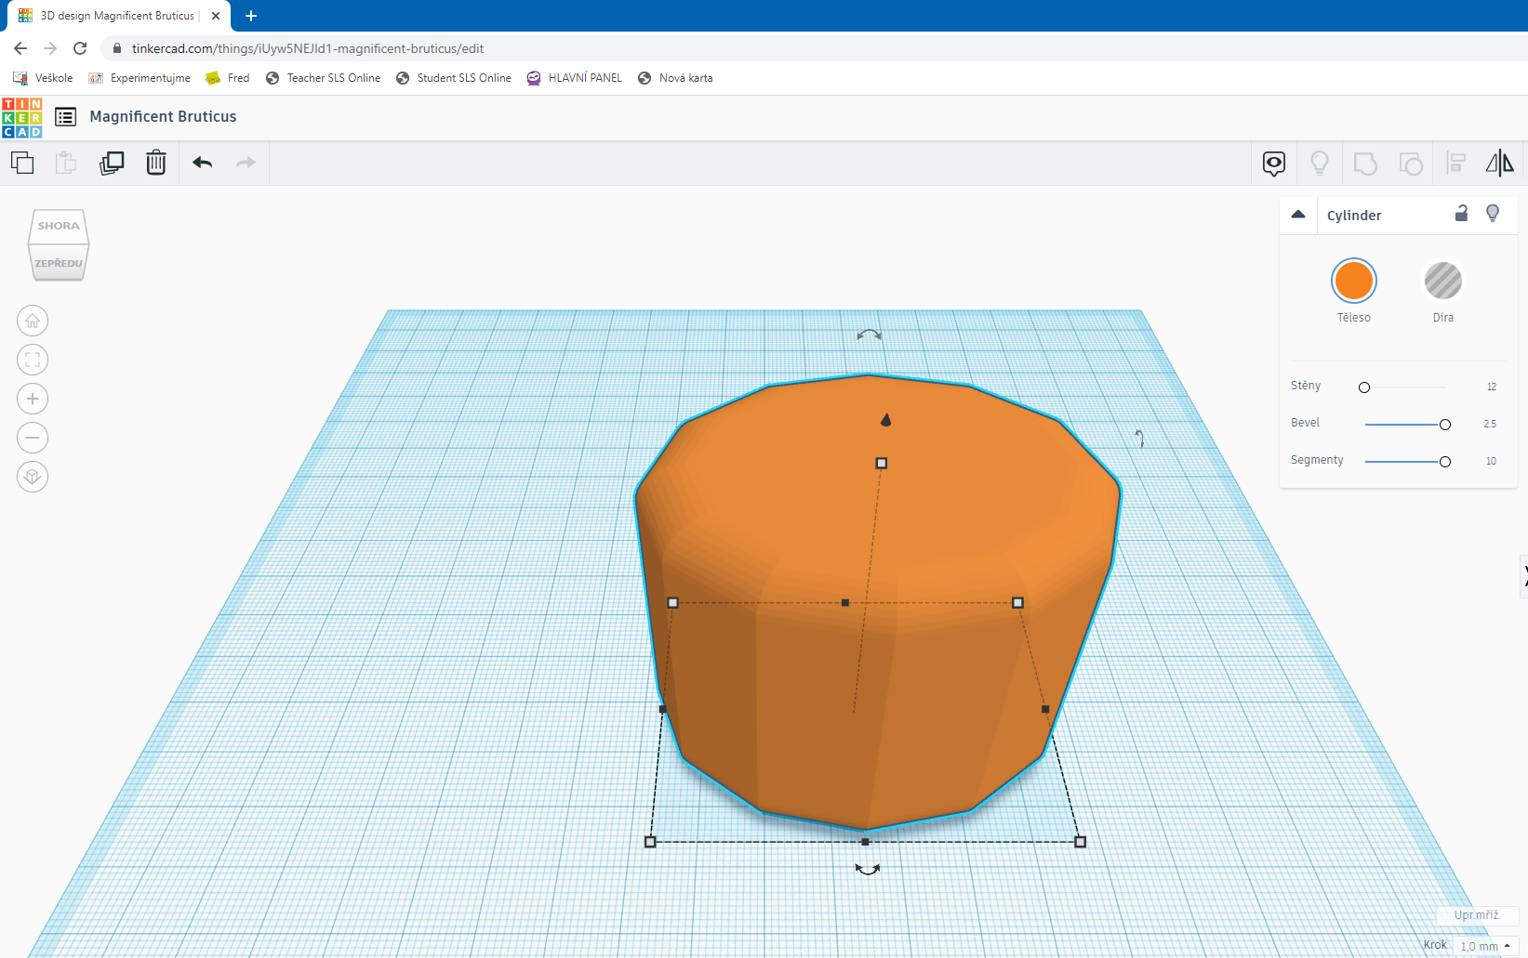
A very important function is the intersection and difference operation. Individual blocks can be clipped to each other. The grey menu "hole" is used for this.
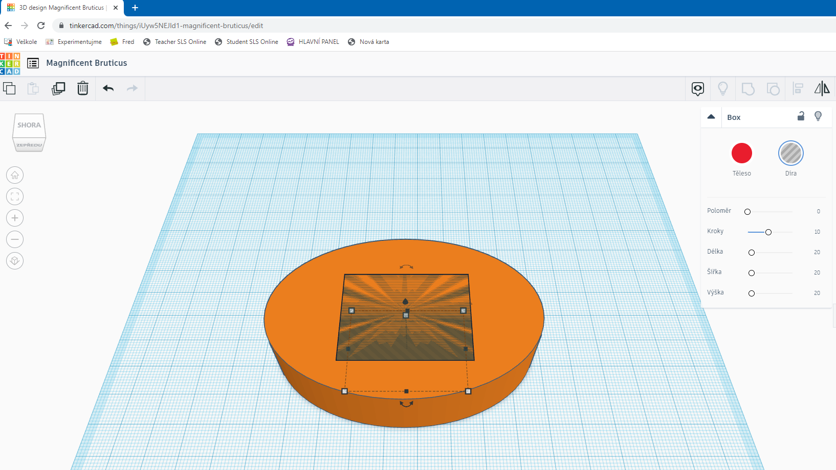

After grouping both objects, clipping occurs.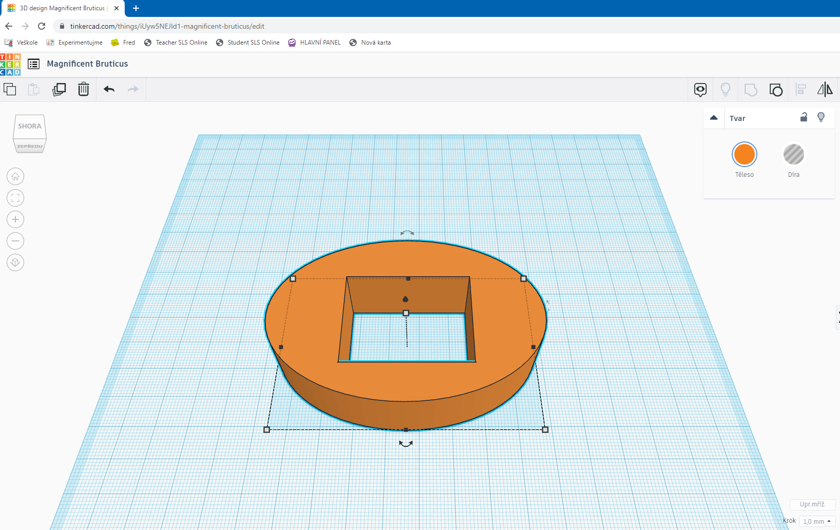
An irreplaceable role is played by the "grouping" function, when we can insert several building blocks from the library into one object.
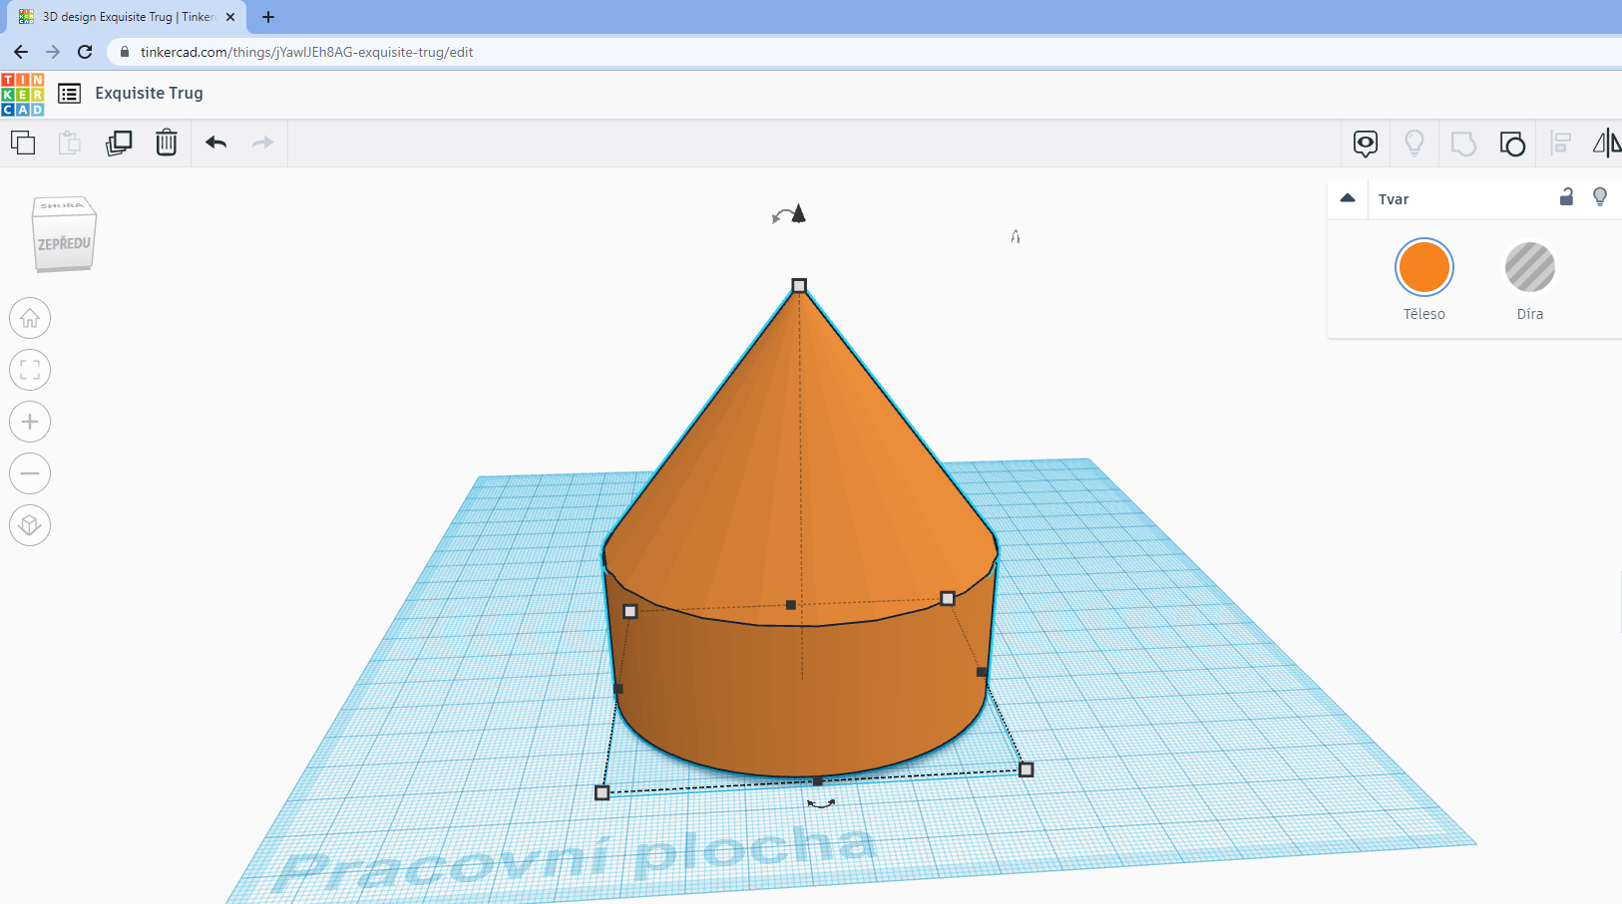
After creating the desired 3D model, we need to import it in .STL format for further use.
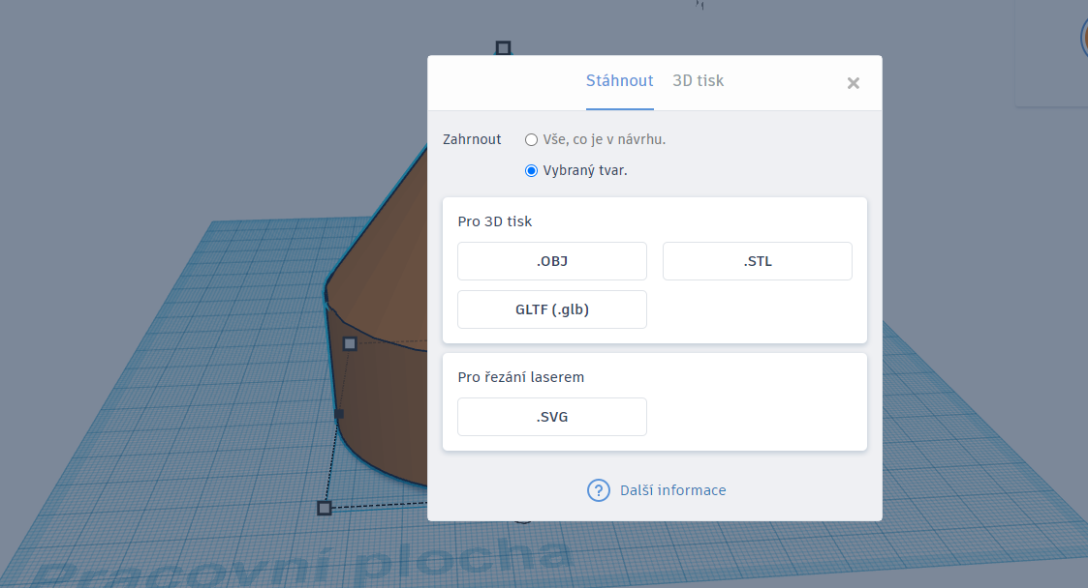
In addition to creating our own 3D objects in the Tinkercad program, we also used the offer of ready-made models in the project, which we further modified.
- The main sources for us were the sites:
www.printables.com
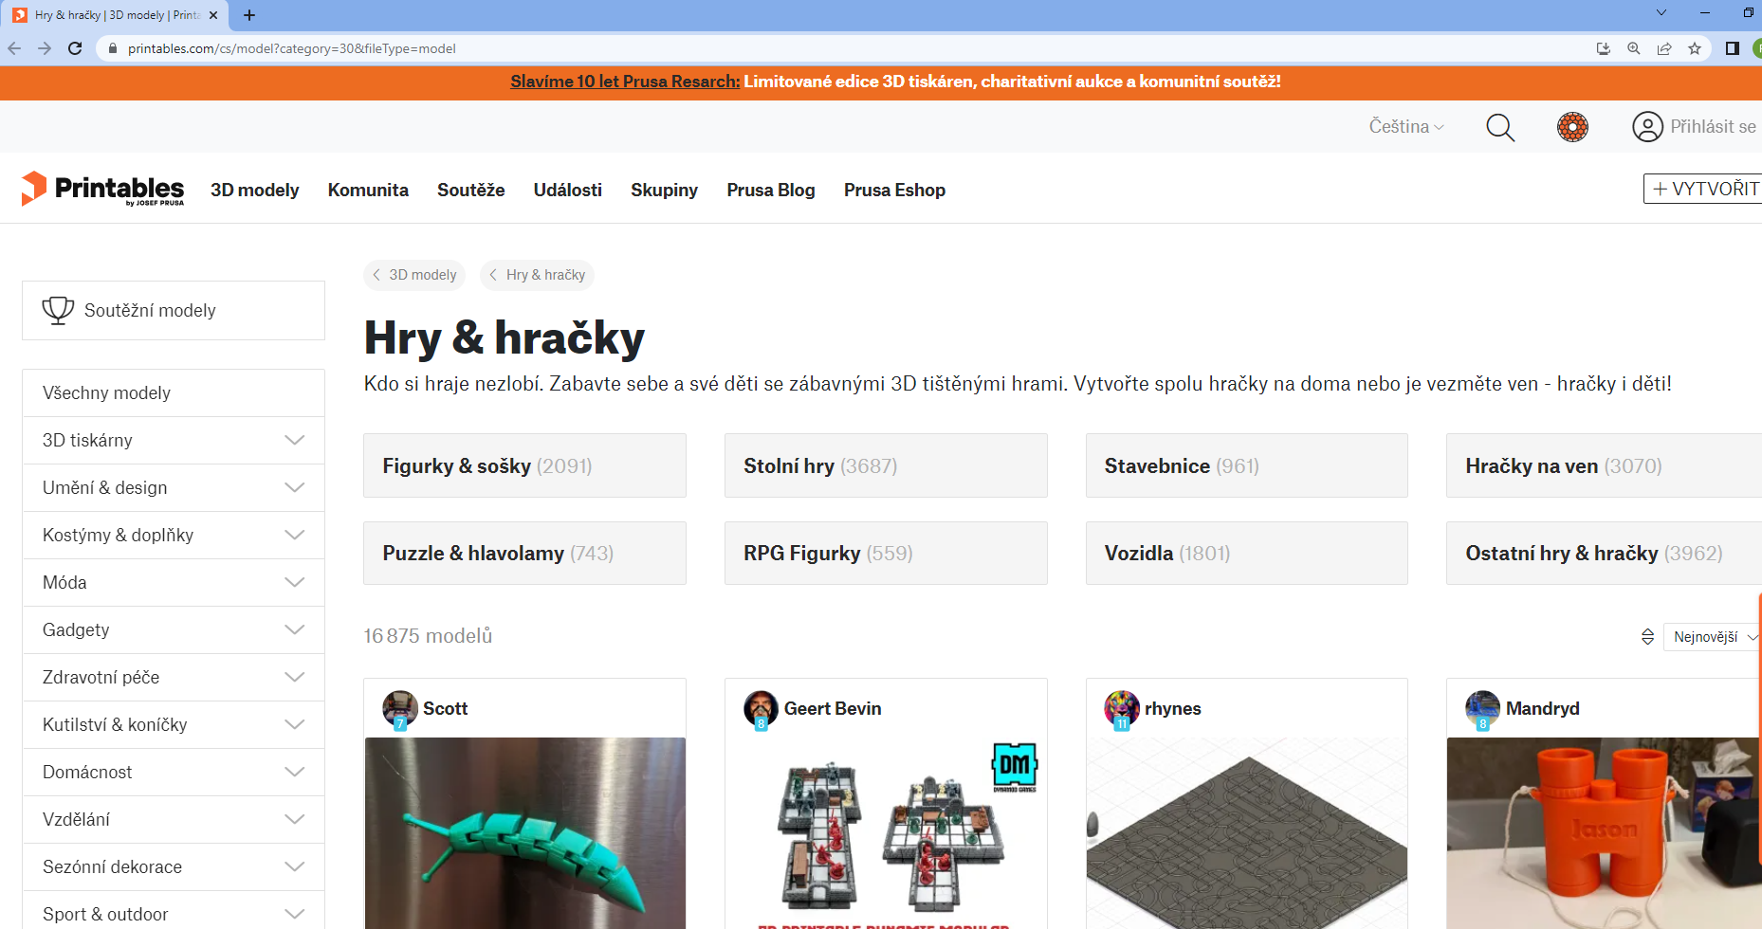
- www.thingiverse.com
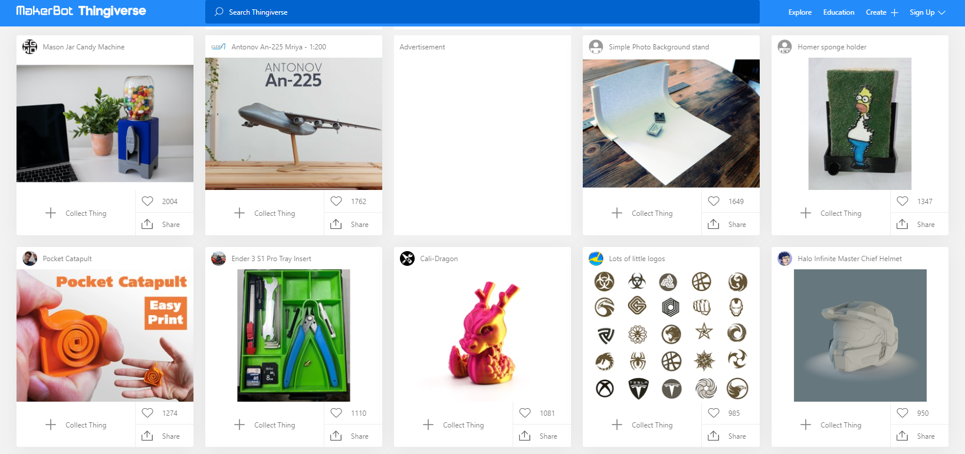

PrusaSlicer

Whether we created the 3D model ourselves or downloaded it from the internet, the 3D geometry (.STL) needed to be converted into a set of printer instructions known as G-code. We used the already mentioned PrusaSlicer. As the name suggests, it is a slicer from Prusa Research itself, based on the open-source Slic3r project.
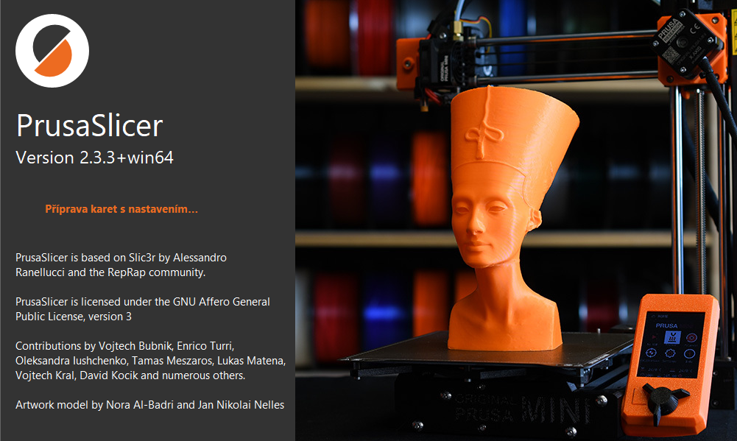

The G-code file contains information about the movement of the extruder, the amount of filament needed to make the object, the temperature setting or the fan speed.

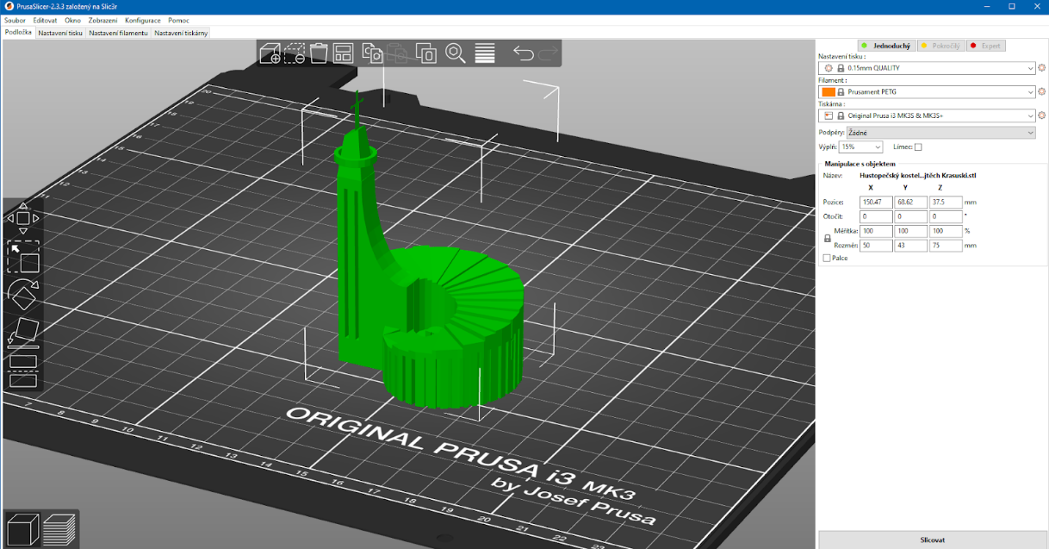
Many print parameters can be set in PrusaSlicer. Those defined by us in our project primarily include:
- print quality - we printed the objects on our map mostly in the highest quality

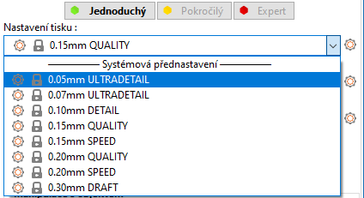

- filament settings – all grey and black objects are printed with PLA filament, the remaining colours are printed with PETG

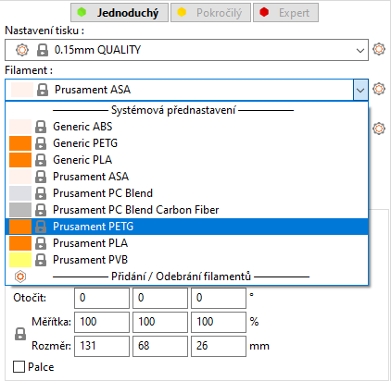
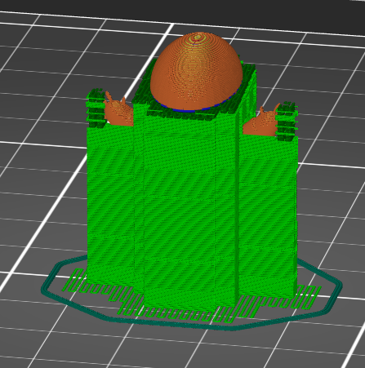
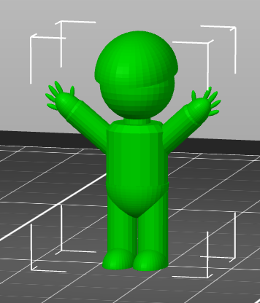
- supports - this function was very important for the correct printing of many objects on our map

- size and scale - in perspective to our base map, it was also essential to think about the sizes of the individual models

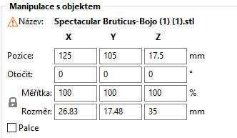

- fill – most objects printed via "gyroid"

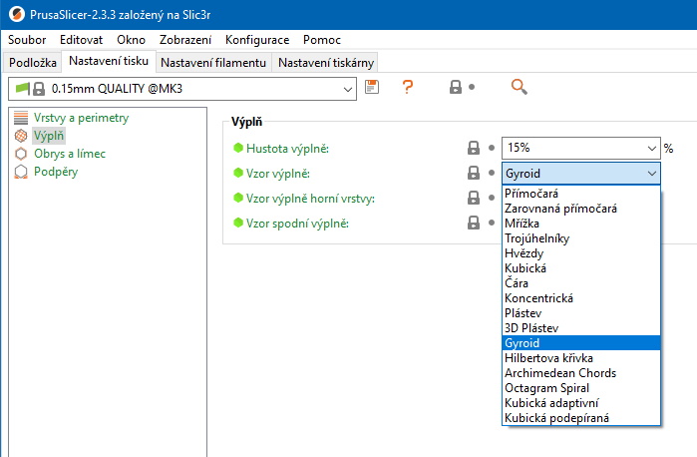

Creating a base map

At the stage when it was already clear what places we would present using 3D models, it was important to work on the creation of the background map. The size of the printed models also depended on its size. It would not be appropriate for the models to occupy a large area on the map, but they could not be too small in size to get lost on it.
We used the services of a local advertising agency to create the background map. Here they helped us not only with the choice of a website where freely downloadable maps are available (https://openstreetmap.cz/), but also with the choice of material on which the map was printed. It is a PVC sheet measuring 0.3 cm x 130 cm x 90 cm.
In addition to the map itself, we placed a strip on the board with the name of the project and a QR code linking to the online Google Earth map with the vignettes of the individual models and their exact location.
Pic. Sample of the final form of the map background without 3D models
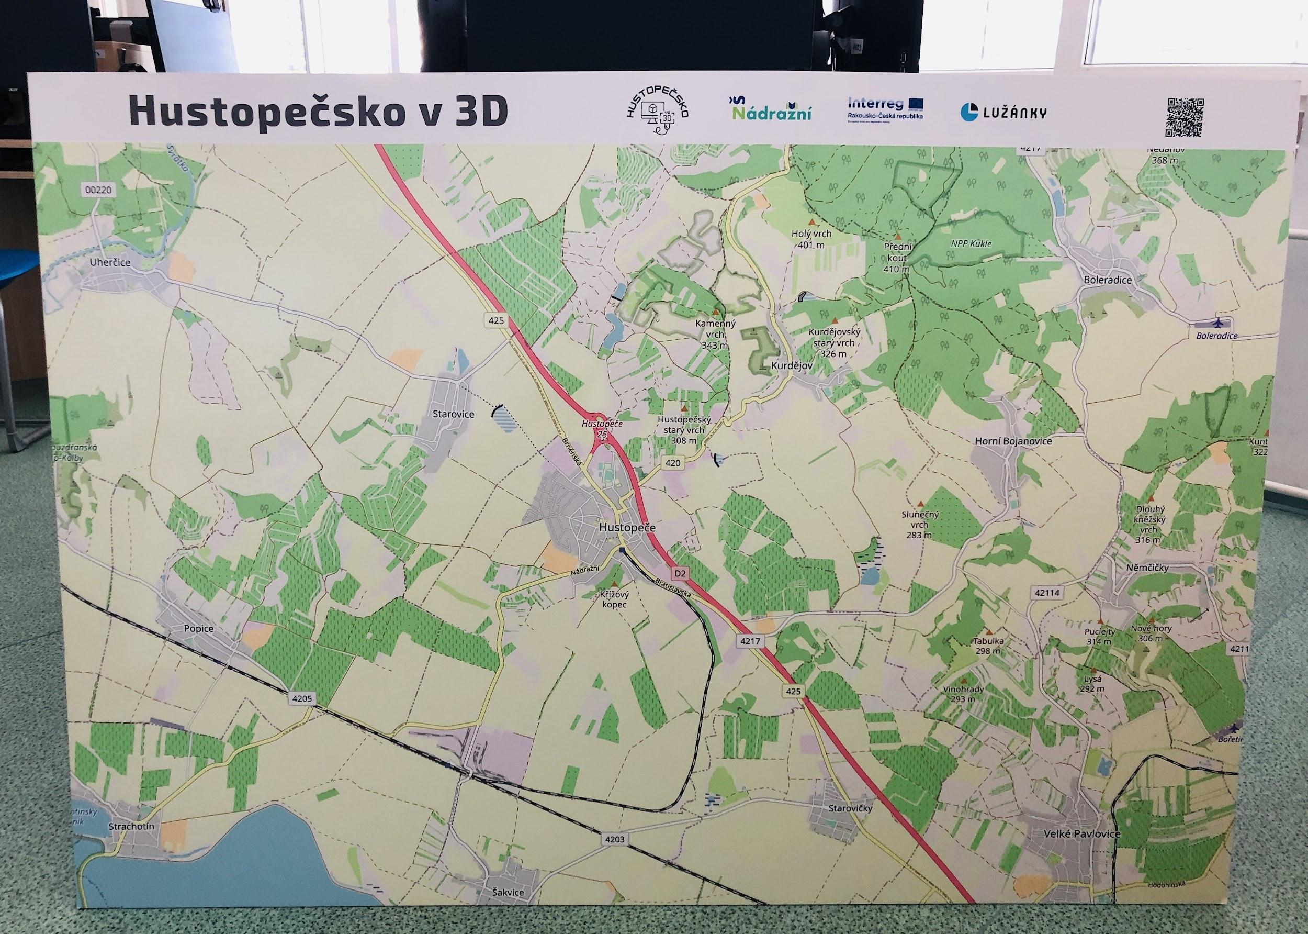

Online map and its creation

Our project has two final outputs that complement each other. This is a map of the Hustopeč region with printed 3D models and an online interactive map on which the visitor will find vignettes of individual models, the places to which the models point.
When creating an online map, we decided between two options – Google Maps and Google Earth. In the end, the choice was Google Earth, mainly for aesthetic reasons. The graphics themselves, moving between objects, displaying labels, photos and vignettes on the map in the Google Earth application are graphically very well done. A minor disadvantage may seem to be the need to download the Google Earth application to view the map on a mobile device. However, it works fine in a web browser on a PC.
To create your own map, you must have an account created in Google Earth, of course you can log in to your own google account. The account owner's name is then displayed on the map itself, which is why we used a newly created account called DigiMe to create it.
The screenshot below shows our online map called Hustopečsko in 3D. On the left in the description, we have stated the purpose for which it was created and what it actually serves. Below the annotation are individual map points.

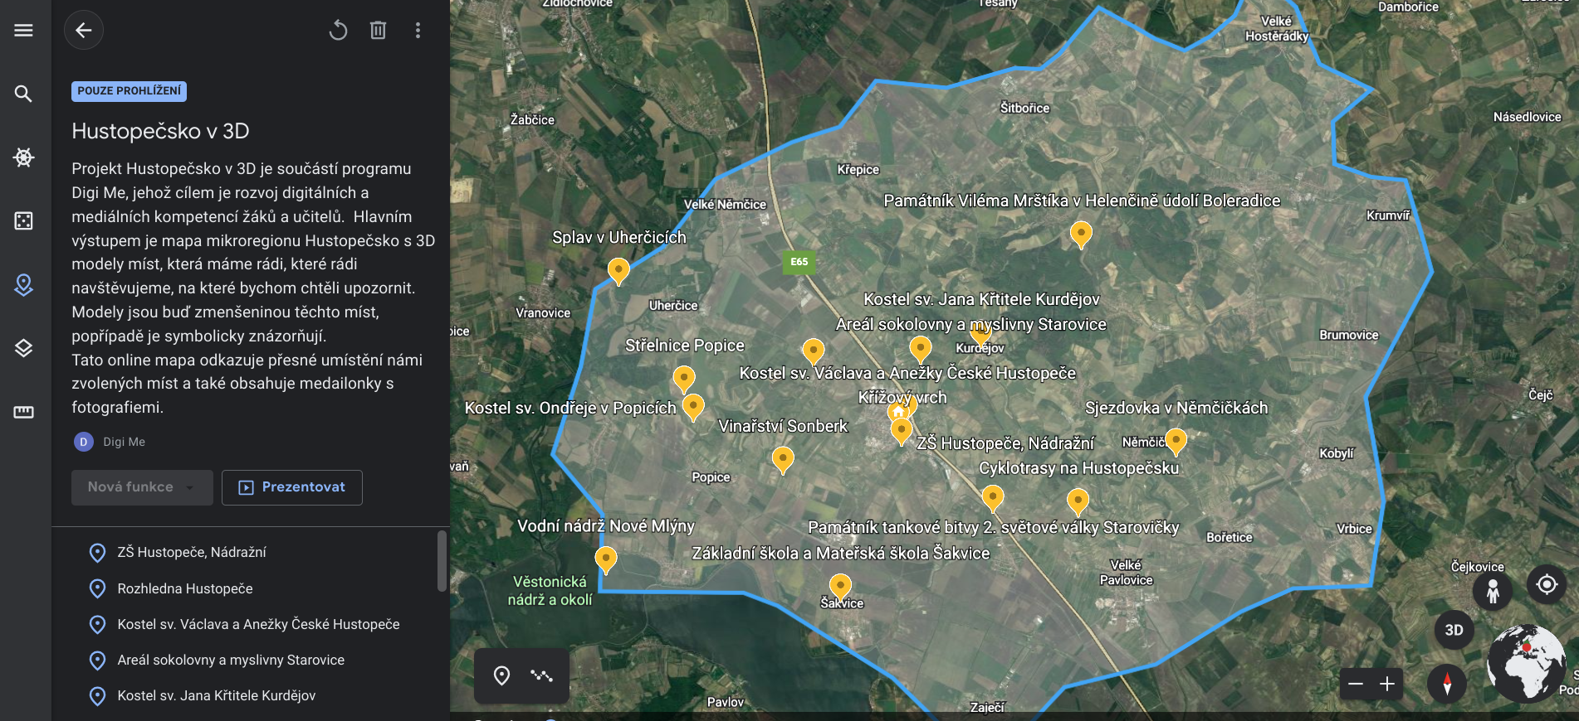
The blue line on the map outlines the Hustopečsko microregion, in which our places are located.
By double-clicking on a point in the application, you will be transferred directly to the given place on the map on the right, and you will see the photo we inserted and a vignettes of the place, which was also created by the students. (See image below.)
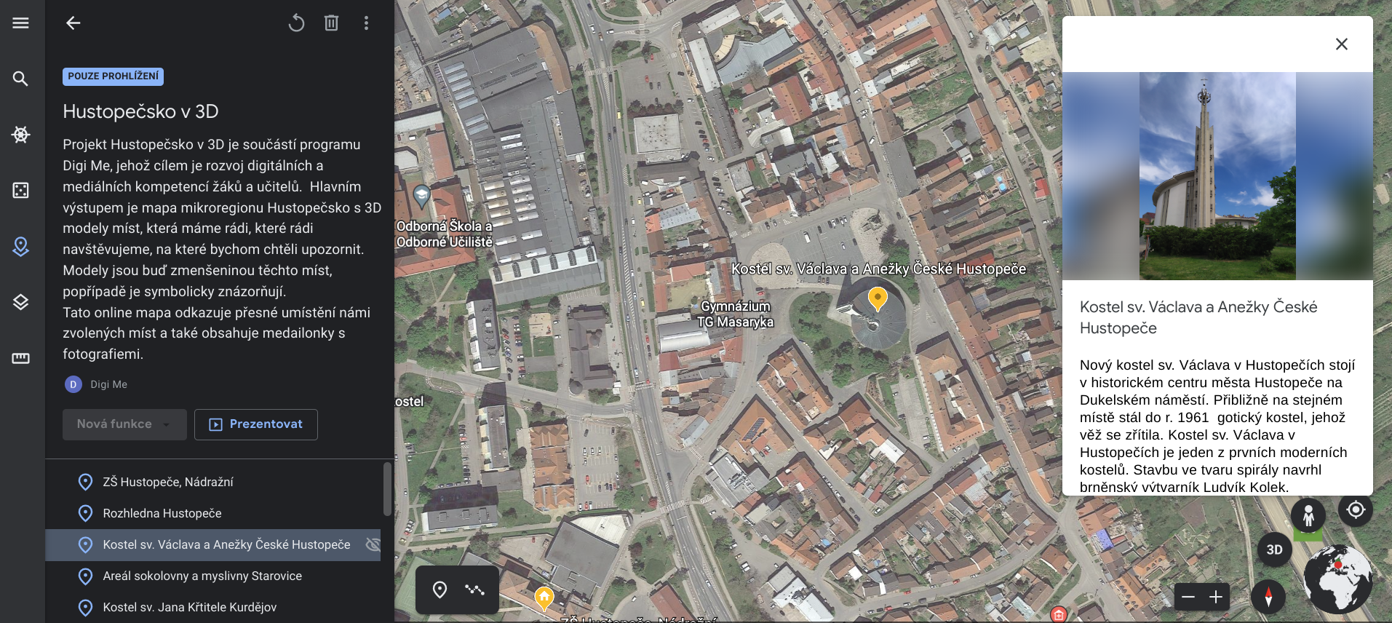
To create a map in the application, login and select the "Projects" icon on the left of the toolbar.
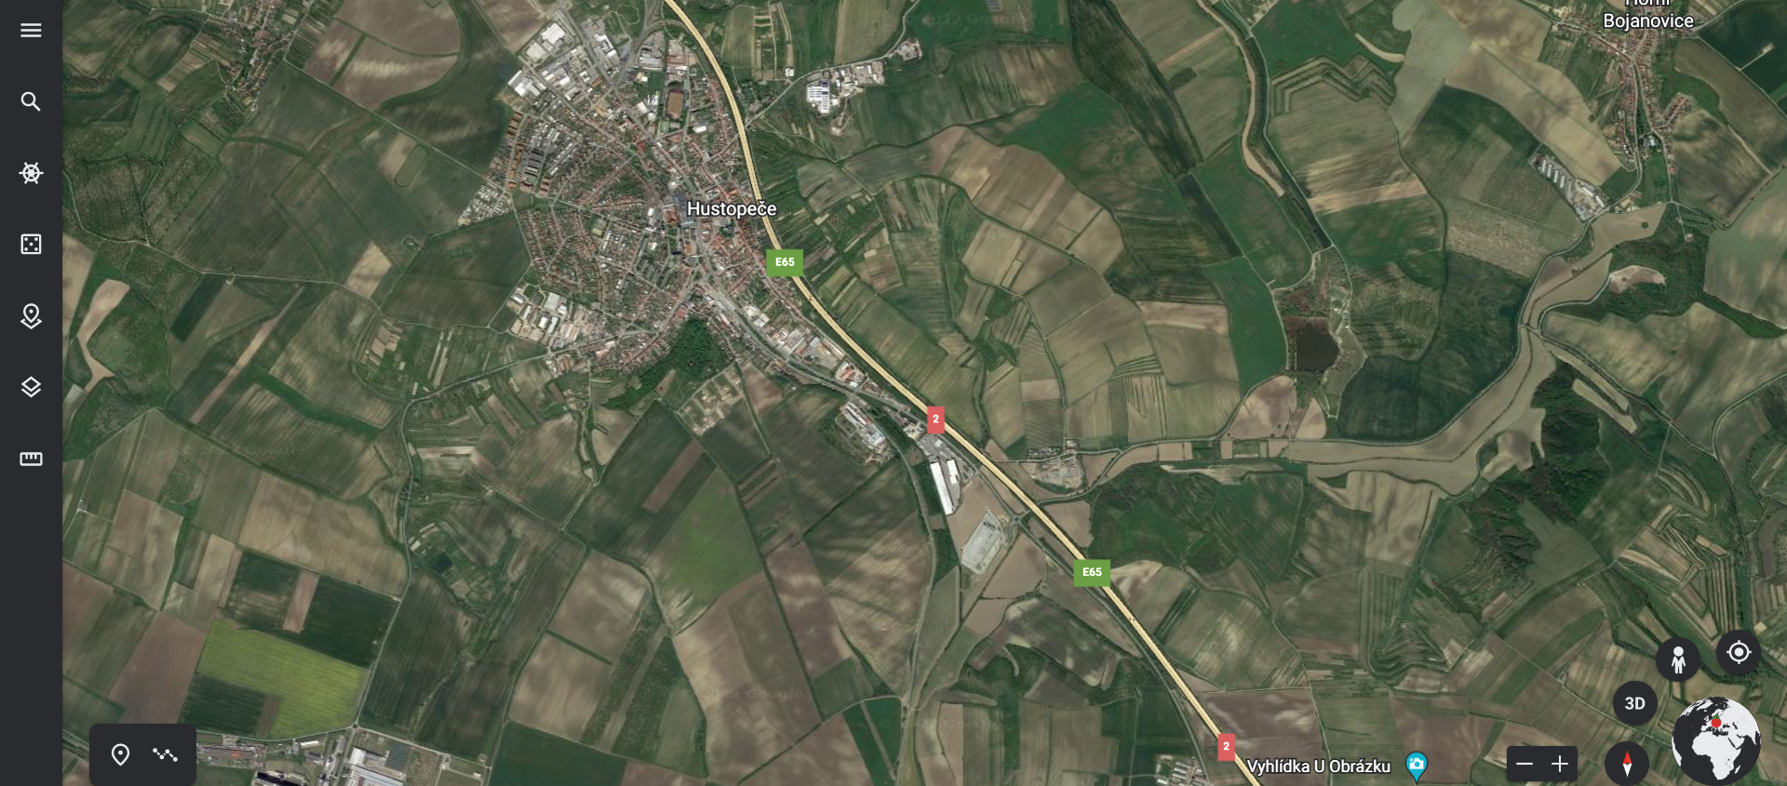

Enter the option New project - Create on google drive and you can start editing your own map. Enter a project name and description. Now you can add individual points to the map. If, like us, you want to use the boundaries of a certain space on the map, click on the icon in the lower left corner of the map section, which is used to "draw a line or shape".

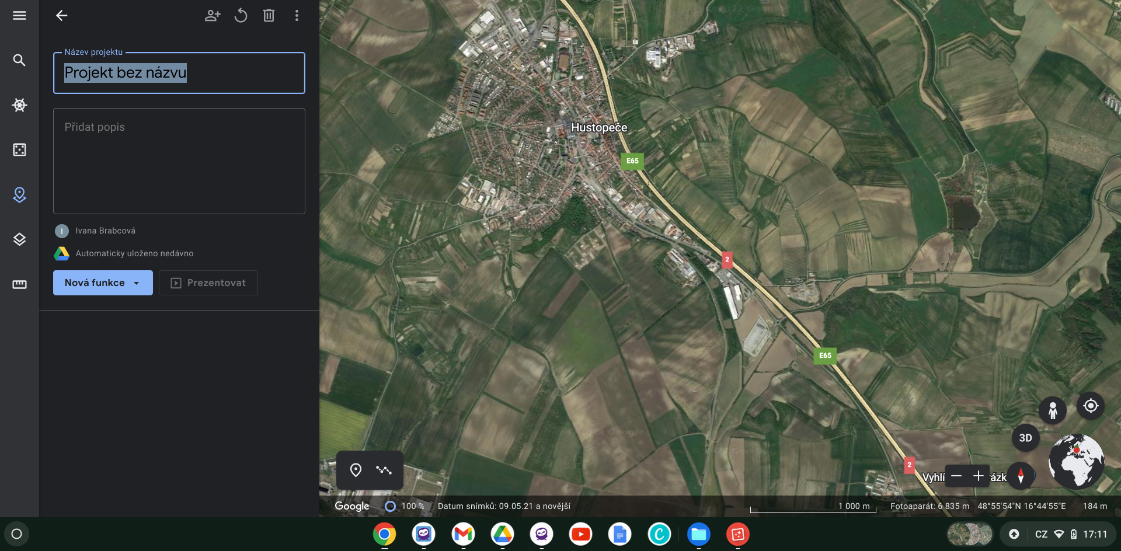

Now you have the map ready and you can add points. Use the magnifying glass to find the location you would like to have listed on the map. The app will take you to it. After that, just click on the "Add to project" menu.
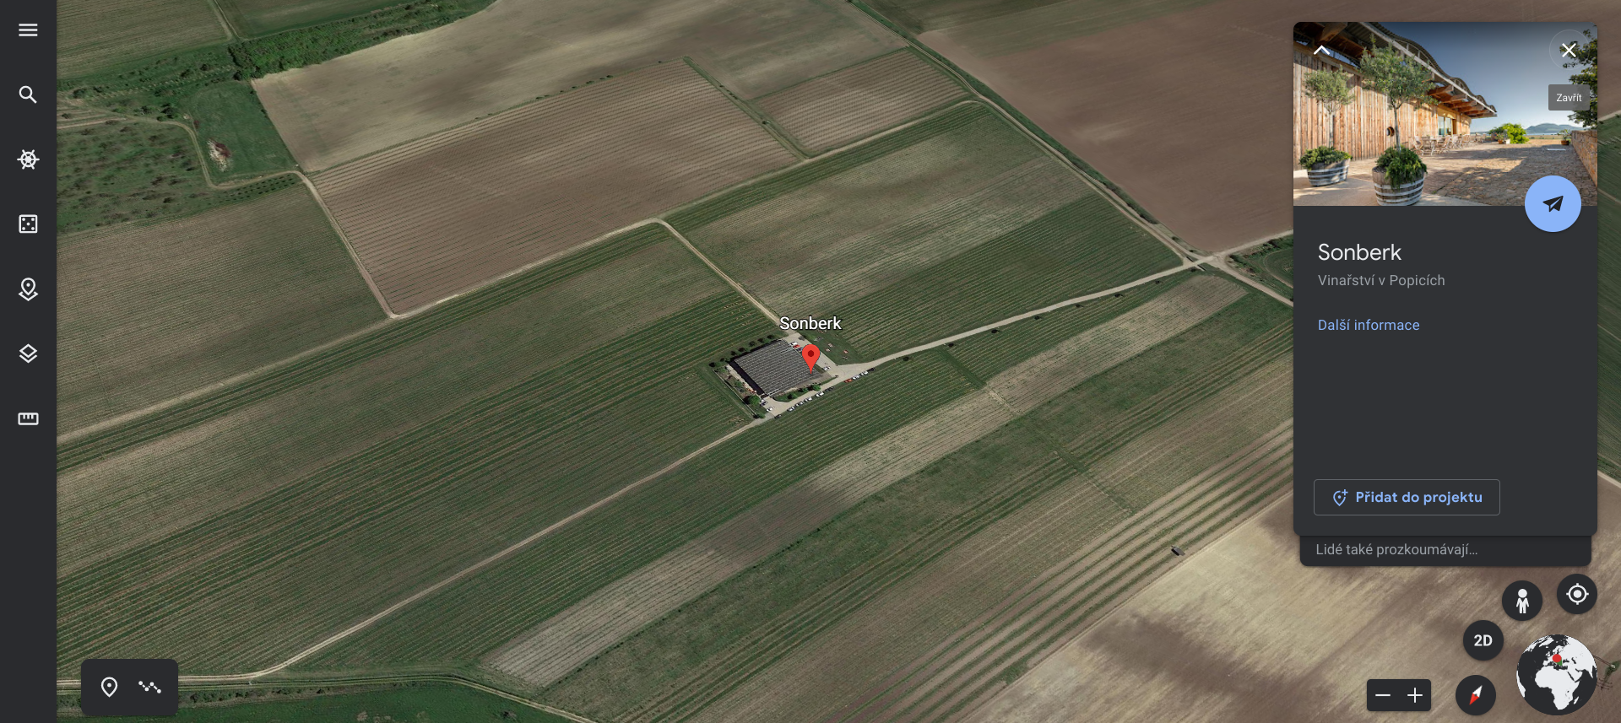

If you want to add your own photos, videos or captions to the location, you must select the Replace option and then save the changes by clicking on the Restore Defaults label at the bottom of the page.
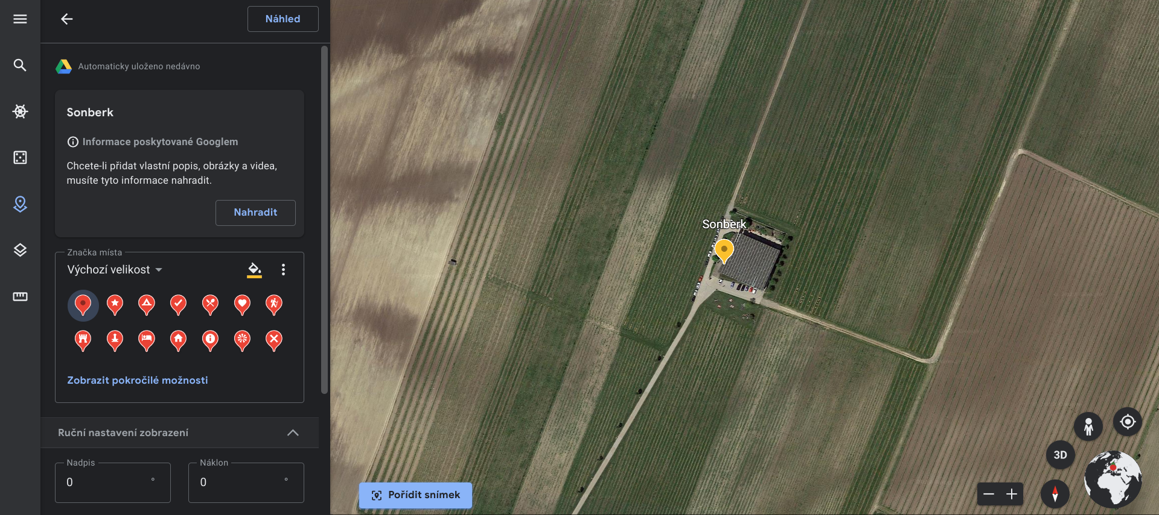

It continues in this way until you have inserted all your selected locations on the map. As soon as you want to publish the map you can just copy a link and share it. You can get the link by clicking on the share project icon. If you will be sharing the link on a web page, select the option All users who have the link.
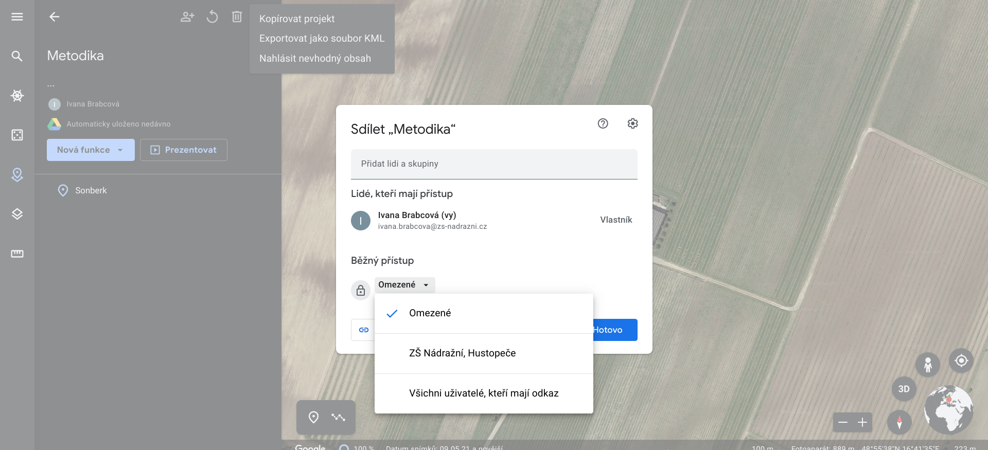

You now have a map created and ready to share. To share longer links, it is advisable to use the option to create a QR code from a long link. The QR code generator is used for this. The Google Chrome browser has already created an automatic function of generating a code from the currently viewed page, just right-click and select the option "Generate QR code for this page". Alternatively, use one of the many websites for code generation. E.g. https://www.the-qrcode-generator.com/.

Final outputs of the project

- Physical map with 3D models
- project website
- Online map in Google Earth

A physical map with 3D models is displayed in our school.
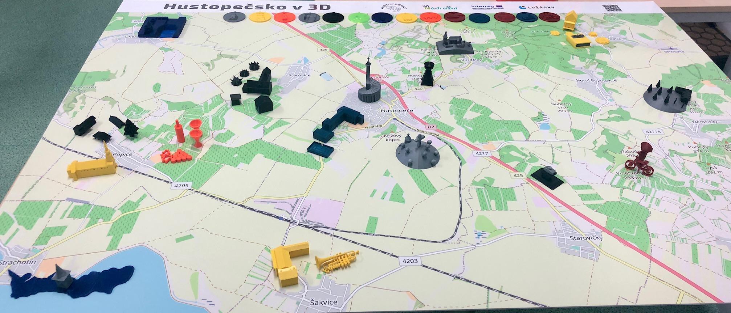
As already mentioned in the chapter Preparing the project, for the presentation of the final outputs we used, among other things, a website, which was founded, created and managed by members of the student team. You can find information on how we progressed in the project in one place – Project Diary. We also share photos and videos on the website that we used for the presentation. Here, the visitor will find a link to an online map in the Google Earth application and, last but not least, links to articles that inform the public about our project.
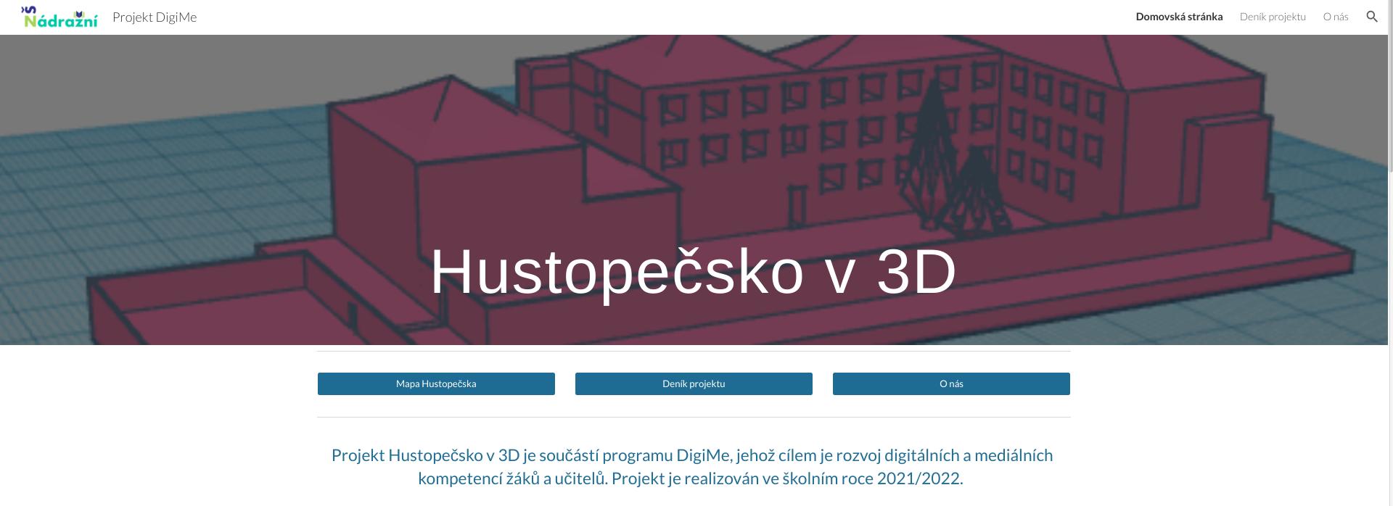
You can visit the website at:
https://sites.google.com/zs-nadrazni.cz/hustopecsko3d

Summary - benefits and pitfalls

The implementation of a student project is one of the teaching methods that targets and transfers the activity directly to the students themselves, regardless of the student's knowledge, because project methods enable the involvement and application of even weaker students. Students enjoy working on projects, because here they see the complexity, continuity with reality in a practical environment. They see the applicability of acquired experience and knowledge, abilities and skills in real life. They are the driving force here. They enjoy working on the project. As part of the project activities, a number of key competencies are developed, especially personnel and social. Students are responsible for their work and they work together in a team. Students develop creativity, the ability to respond to changes, and learn to solve problems.
For teachers, leading a project team means an increase in the preparation and additional time, plus the teacher's pedagogical skill is also important here. He stands here in the role of a partner, an advisor. The teacher should guide the students, motivate them, offer them opportunities, advice, tips that the students may or may not use. The students needed the most support at the stage when the project was coming to an end, and all outputs needed to be completed. The more printed, more often defects and malfunctions appeared on the equipment (clogged nozzles, calibration of individual axes). Here, the teacher was an integral part of the team, it was necessary to motivate the students more, to help them, but still leave most of the decision-making and work to them.
In order to implement such a project, the school needs to have sufficient facilities and equipment. The DigiMe project enabled us to purchase equipment. Thanks to involvement in the project, we not only have the equipment itself, which we can continue to use both in teaching and in the informal education of students. Students and teachers have the opportunity to work with the device as part of teaching their subjects, such as work activities, computer science, physics, etc. Depending on their interest, the device is also available to students after class. In our school, a wider team of teachers from different subjects was formed who collaborated with the students on the project. The implementation of the project found its place in the subjects of mathematics, Czech language, civics and art education, physics and computer technology. Last but not least, through the implementation of our project, its presentation on social networks and in the local press, the school's prestige has risen. The public response to our activity was very positive and encouraging.
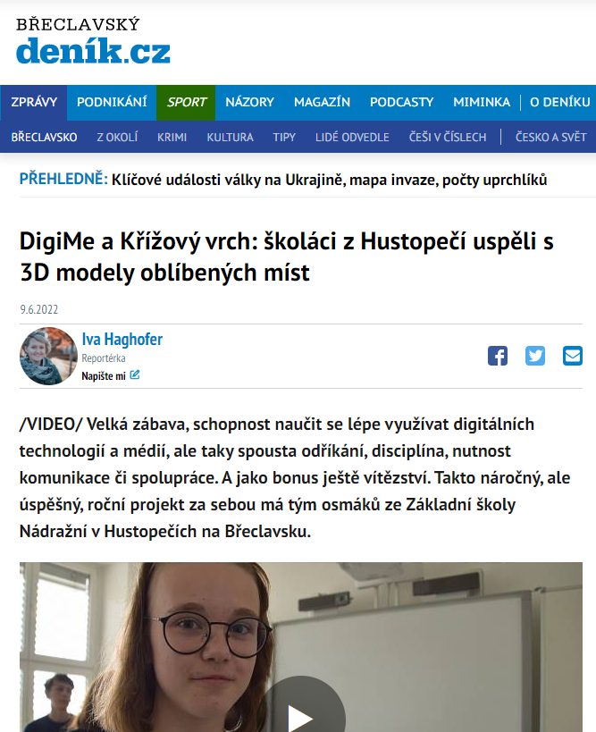

All the people from the project have come a long way during the implementation. It was a big challenge at the beginning, we were entering unknown waters, both students and teachers who had no experience with 3D printing technology. The goals that were set at the beginning were achieved:
- Purchase new equipment and material for 3D printing for the school.
- Understand the application of 3D printing in practice and know its advantages.
- Get to know 3D printing technology, its principles.
- To learn to perceive the proportions of various objects around us.
- Learn to work with programs for creating 3D objects, familiarize yourself with the basic control elements of the program, and model your own designed objects.
- Work with 3D models.
- Develop informational thinking.
- Develop technical thinking.
- Get better at working with an online map.
- Learn how to create a simple website.
- Work in a team, develop social, communication, digital and work competences.
- Get to know and present our region through lesser-known places.

Now we have a final product in front of us, of which we are rightly proud.
All members of the project have come a long way during its implementation. It was a big challenge at the beginning, we were entering unknown waters, both students and teachers who had no experience with 3D printing technology. The goals that were set at the beginning were achieved:
- Purchase new equipment and material for 3D printing for the school.
- Understand the application of 3D printing in practice and know its advantages.
- Get to know 3D printing technology, its principles.
- Learn to perceive the proportions of various objects around us.
- Learn to work with programs for creating 3D objects, familiarize yourself with the basic control elements of the program, and model your own designed objects.
- Work with 3D models.
- Develop informational thinking.
- Develop technical thinking.
- Get better at working with an online map.
- Learn how to create a simple website.
- Work in a team, develop social, communication, digital and work competences.
- Get to know and present our region through lesser-known places.
Now we have a final product in front of us, of which we are very proud.

